1. **SoftBlog**

**Environment Specifics**

Please, be aware that every JS environment may **behave differently** when executing code. Certain things that work in the browser are not supported in **Node.js**, which is the environment used by **Judge**.

The following actions are **NOT** supported:

* **.forEach()** with **NodeList** (returned by **querySelector()** and **querySelectorAll()**)
* **.forEach()** with **HTMLCollection** (returned by **getElementsByClassName()** and **element.children**)
* Using the **spread-operator** (**...**) to convert a **NodeList** into an array
* **append()w** in Judge (use only **appendChild()**)

If you want to perform these operations, you may use **Array.from()** to first convert the collection into an array.

### Use the Given Skeleton to Solve This Problem.

**Note: You Have NO Permission to Change Directly the Given HTML (Index.html File).**

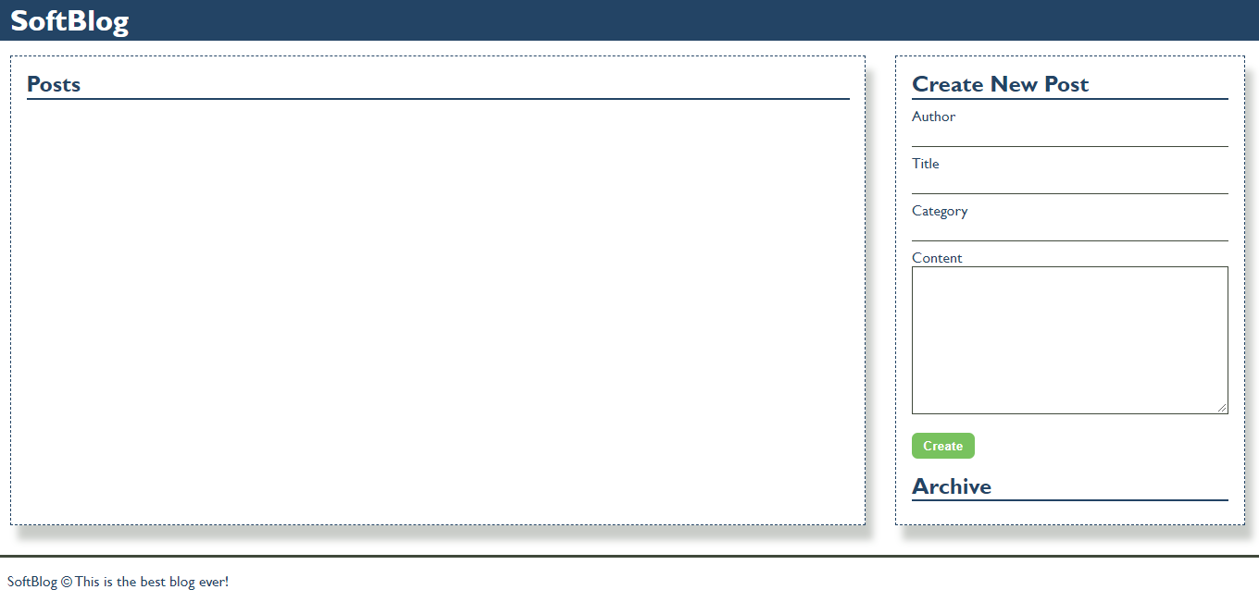

### Your Task

Write the missing JavaScript code to make the Blog application work as expected.

You should be able to **create** new articles.

Each article has **author, title, category** and **content**. When you click the **[Create]** button, a new **article item** should be added to the articles **section**.

The new item should have the **following structure**:

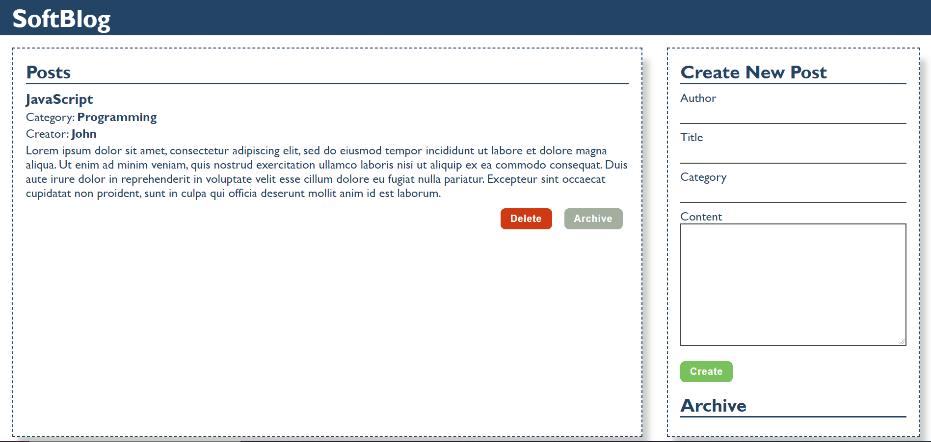

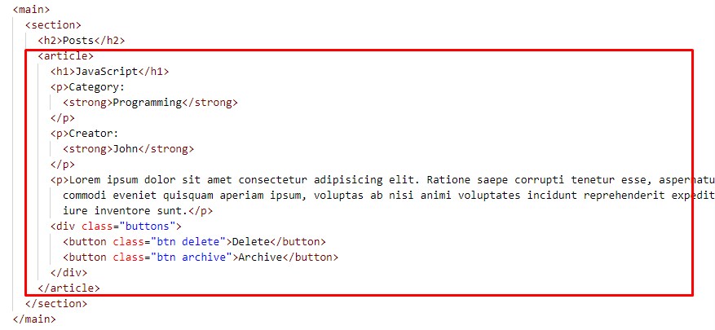

* Append two buttons, which are in a **div** element with class **"buttons"** to each article item
  + **[Delete]** button should have the following classes: **"btn" and "delete"**
  + **[Archive]** button should have the following classes: **"btn" and "archive"**

When you click the **[Archive]** button you should move the article to the **ol** in the archive section. Archive section should be **sorted by title**.

**Important! Do not move the entire article, but only the title of the article.**

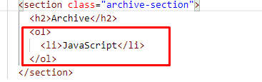

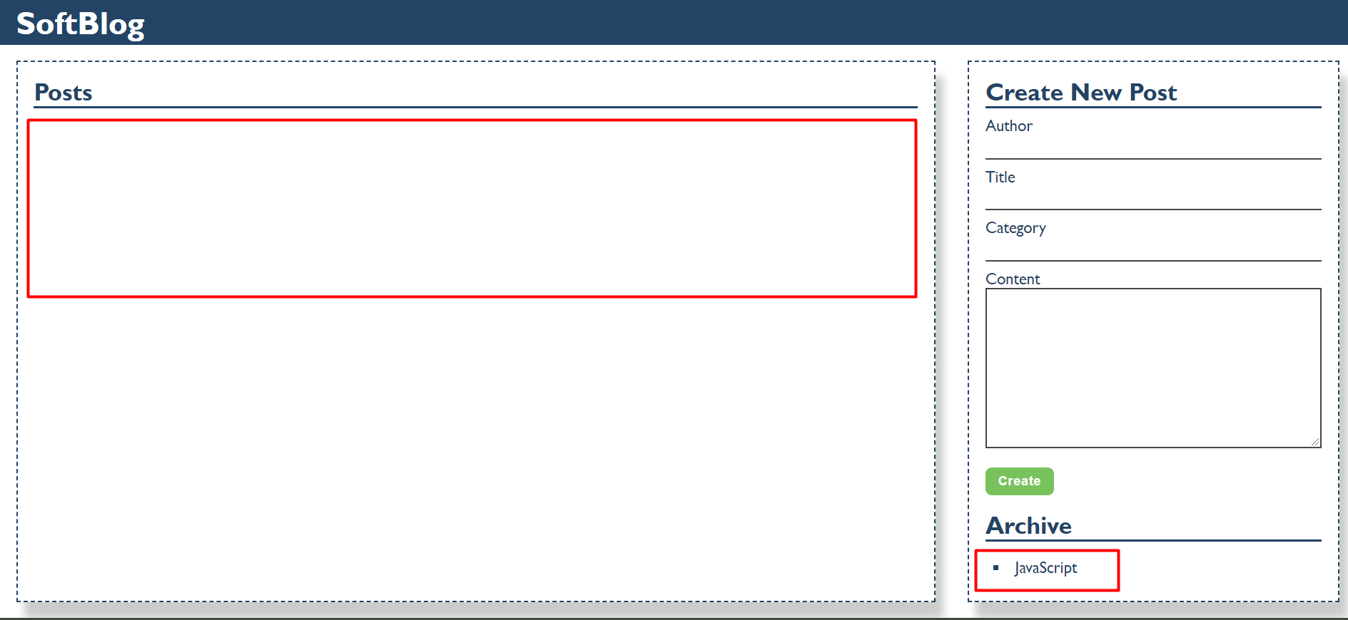

When you click the **[Delete]** button you should delete the entire article.

